Survey Funnel Formula Week 6 Outline / Notes

Today’s topic: EMAIL

Email is a BIG part of the Survey Funnel Formula…

- Depending on the market I’m in, I’ll pick up anywhere from 25% to 75% of my sales from email…

Why is there such a variation?

MARKET DYNAMICS

- If you’re more in a problem/solution market, you’re typically going to see more sales on the front end
  - –example- wart removal solution – people need it removed ASAP
- If you’re in an ENTHUSIAST market – (bass fishing, internet marketing, etc.) Where people enjoy reading about the subject matter again and again…
  - You’ll find that you’ll capture a higher proportion of your sales on the back end through email

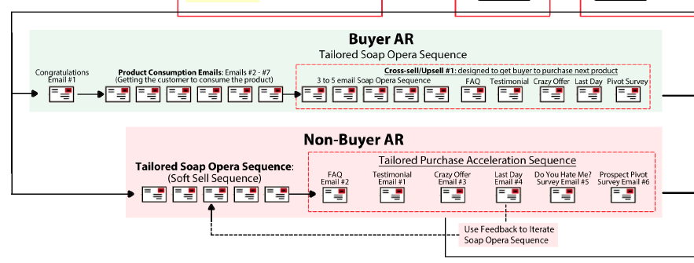

Email Formula

There is a Go-to set formula/structure when I build my buyer sequence as well as my non-buyer sequence – and I’ll be walking you through the formula/template for structuring these campaigns in just a little bit…

Email is a DEEP topic – we could focus on it for weeks (and I might teach another 6 week course just on email)

But today I want to give you enough actionable info to get started…

Prospect Sequence

- This is the sequence that’s the most tricky…

BUT – it’s the one that’s going to give you the biggest bang off the bat
- b/c if you don’t have one of these in place, you’re leaving anywhere from 25%-75% of your revenue on the table

WHY? – b/c for whatever reason, many people won’t be ready to buy right after that Same Visit Sale VSL…

- The vast majority go through the whole pre-sale part of the funnel – but they still don’t buy – not because they’re not good prospects, but because maybe they need a little more coaxing before they trust you and are comfortable spending money with you…

And email is the PERFECT medium for establishing this kind of relationship

The 3 big elements of the Prospect Sequence

You can divide the prospect sequence into 3 different parts, and the 3 parts correlate to what I like to call,

A Temperature.

So at the beginning, you have what I call…

#1 The Low-Temp Section

This is where you’re romancing your audience with story.

They didn’t buy from you on the first point of contact on that first offer, so you need to take a step back…

And the way I do it is…

Don’t be aggressive right out of the gate with email

Instead, I like to rope them in – and get them ENGAGED with me, speaking with me so I have a captive audience

I keep it “Low Temp” which means I’m not slamming them over the head w/ aggressive offers…

Instead, what I’m doing is using stories – sometimes these stories even seem irrelevant…

- to get them opening the emails, get them engaged, get them reading my emails…

And I will SUBTLY throw in a “oh by the way, you might be interested in checking out my XYZ product” But not making that the central reason or theme for the email

[12:43]

We’ll go through a few exmples of this storytelling & romancing in a few different markets…

#2 Medium Temp Section

This is where you’re turning up the heat a little bit, but we’re not getting into aggressive ‘slamming them over the head’ with the offer…

BUT – we’re beginning to be a little more direct…

Again, beginning of sequence (part #1) is more story driven – to pull people in…

THIS #2 section, though – we begin to articulate the offer…

- We’re more focused on re-explaining what the offer is
- What it is that you’re selling
- And attacking that from a couple different angles

#3 High Temp Section

This is where we turn things up to a full boil…

You’re turning the heat on your prospect, and basically it’s

“Ok, now it’s time to buy.”

Buy, or let’s move on to something else

How do you ‘turn up the heat’?

- scarcity, limited time offer,

But why don’t we turn up the heat right out of the gate?
- for whatever reason, when we presented someone this offer for the first time, they weren’t ready to buy…
  - so if you were to send them an email that same day, telling them to “Buy now!” – do you think they’d be ready to buy?
  - Probably not….
    - The timing probably wasn’t right, so we instead focus on taking a step back and building engagement and romancing them a bit more

/////// End intro //////

Importance of Story

When someone doesn’t buy on the front end…

We’re going to be taking a step back –

BUT we still want to keep them engaged.

And the way we do that is through STORY.

We’re going to talk about how to be a great storyteller – for the purposes of email marketing…

The most successful email marketers use stories

Email Formula for Marketing to Non-Prospects

This formula is a good starting point…

First, we’ll look at the ‘big picture’ and then we’ll get into the details of each email…

Prospect Email Sequence – Big Picture…

Email #1 – Welcome Email

Email #2 – ‘Hey, did you get my email?’

Email #3-5 - ‘Soap Opera Sequence’
- where you’re telling a story

Email #6 - FAQ email

Email #7 – Testimonial email

Email #8 - Crazy Offer / Irresistible Offer

[Then, if you like, some Optional Emails in the middle here]

Email #9 – Last Day Email
- Last day to take advantage of this crazy, irresistible offer…

Email #10 – ‘Do You Hate Me?’ Email

[Optional] Email #11 – Re-Open
- Where we re-open the crazy, irresistible offer for a brief window…

Email #12 – Pivot Survey Email
-We ask where the prospect wants to go from here
- “Clearly you’re not interested, so what else would you like to talk about or learn instead?”

[video timestamp 20:35]

Now, let’s look at things more in-depth…

Email #1 – Welcome Email

You want to do a couple things in this email…

- Acknowledge their results from the survey you just gave them…
- Also put a link back to the sales video (back to whatever it is they would have seen after taking the survey – usually your main VSL)
- Whitelisting instructions: To improve the deliverability of your emails
  - Give people a compelling reason why they want to continue to get emails from you…
    - Usually, something like… “Hey, we’ve talked about one thing, but that only scratches the surface… Over the next couple days I’ve got some other great stuff that you want to get… That I think you’re going to love… HOWEVER – Before we do that, I want to make sure that you’re able to get those emails, so here’s what you need to do…”
  - Whitelisting guidelines – what you can ask people to do that will improve your email deliverability
    - Have them take action –
      - ask them to ‘star’ the email or
      - create a sub-folder and have them put all those emails into the sub—folder
      - Attach a label to the email or tag it
        - “Make sure to tag all these emails with “Survey Funnel Formula”
    - Note – these instructions are most useful for ‘single-opt-in’ email lists, many times for ‘double’ opt in lists, I don’t do this

Example welcome email:

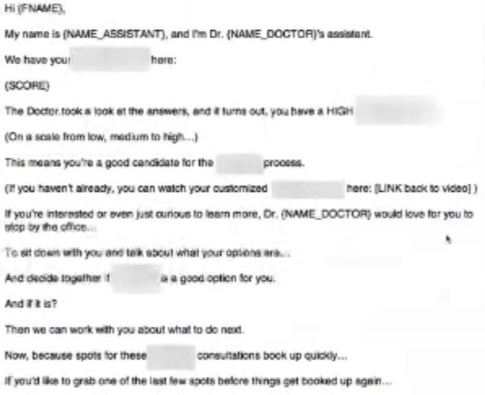

CONTEXT - This is for a funnel for an offer in the dental niche, where we’re running people through a survey to determine if they’re a good candidate for this dental procedure..

Subject line for this email would be something like…

“Your Dental Score… Now What?”

we’re acknowledge that here is their score, and then next steps…

(this isn’t the entire email, just the first part – I had to blur parts of this to protect the client)

Also, look at the merge fields:

{FNAME} = person’s first name
{NAME ASSISTANT} = Assistant name
{NAME DOCTOR} = Doctor name

In this case, we do the Call to action (them calling the dentist) right away in this first email…

We’re not doing much romancing here…

WHY? – This is an immediate problem that prospects are looking to solve ASAP

They don’t need to hear an extended story – they’re going to be taking care of this within the next 24-48 hours…

- kind of like having a leaky toilet – you want this fixed ASAP

Email #2 – Hey Did you Get My Email?

Subject line: hey did you get my email…
(all lowercase, as if you were firing off a quick email)

About 2 to 4 hours after I send that initial email out, I like to send a follow-up email…

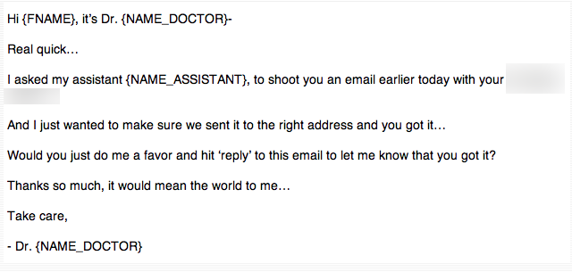

“Hey Pam, it’s Dr. Smith…

I asked my assistant Sheila to send you an email earlier with your Dental Score.

I just wanted to make sure we sent it to the right address and that you got it…

Would you just do me a favor and hit ‘REPLY’ to this email to let me know that you got it?

Thanks so much, it would mean the world to me.

Take care,

Dr. (NAME_DOCTOR)

[video timestamp 30:00]

The reason why I like to send that email as a follow up –

Reason #1 – Whitelisting tactic – Asking them to ‘reply’ to this email makes it look like a REAL conversation
“Hit reply to let me know”
- this DRAMATICALLY increases deliverability rates…

Google/Yahoo etc. see this as a real conversation –

Reply to their reply Have their reply go to a monitored email inbox, where you reply back to them
- maybe you outsource this to a teammember –
  - reply at a minimum, say something like “Awesome, got your reply, thanks!”

Doing this DRAMATICALLY increases open rates / deliverability rates
- more emails will get to people from here on out in the sequence

Key Point – The more you can make this email look like it was an email sent out from you … the better the response is going to be
- if you’re sending the rest of your emails with a fancy template, this is the one email you want to make look VERY plain – as if you just logged into gmail and pumped it out…

Taking this a step further…

- whether or not you’re comfortable doing this…
  - if you REALLY want to give the appearance that this is coming from a personal message, add the text at the bottom, “Sent from my iPhone”
- If you don’t feel comfortable with that, log in to Aweber and write it on your iPhone, and send it into Aweber – so technically it IS sent from your iPhone

Reason #1 – Lets them know there’s a real person there – this goes a LONG way…
- it’s REALLY important

- and it also allows you to triage emails as they come in – in case there are some technical issues – like video isn’t loading, link is broken, etc

Recap – welcome email goes out right away, this email goes out on a 2-4 hour delay

Email #3-5 – Soap Opera Sequence (SOS)

We’re going to walk through one of my marketing emails to get a sense of the storytelling process

Subject line: “What I found in my attic last weekend…”

- good curiosity angle (got 65% open rate btw…)

BUT – what does this subject line have to do with marketing?
(this was for my marketing list)

- what I like to do is write about things that are not immediately connected to the topic you’re writing about at hand…

- if you can take something that is completely unrelated to whatever it is that you’re talking about…

  - What you want to do is take a topic that people in that market can relate to in some way shape or form…
    - And relate it back to your topic at hand in a way that’s not immediately abundantly obvious…

Now I’m going to walk you through this email and explain why it’s structured the way that it is…

So last week, my wife was freaking out.
Because while I was away in Vegas for my O4 Mastermind…
Apparently, she heard “foot-steps” in our attic…
And my wife?
Has gotta have like, the most vivid imagination ever…
Because she’s thinking the absolute worst…
So we call a guy.
Basically “Billy the Exterminator” Texas edition.
He comes to check things out.
His take?
We’ve gotta ‘possum up there.
(But we don’t need to worry - because apparently possums have the lowest core body temperature of any mammal - so they don’t carry diseases… And they’re nomadic. So our “guest” should move on in a couple ‘o weeks.)
But at this point?
It doesn’t matter…
Because my wife is COMPLETELY freaking out.
The moment the words “human-like skin” and “opposable thumbs” enter the conversation…
Her suitcase is half-packed.
Then the guy hits us with his quote to “take care of things”…
The price?
Well, here’s a photo of his quote:
https://www.facebook.com/photo.php?fbid=10100387458945971&set=a.10100120641345581.2282424.1008516
Yeah, exactly.
No. F*cking. Way.
Now, my wife doesn’t even want to pay that kind of money…
So I decide to “handle things” myself…
And armed with my trusty flashlight…
And the seldom used “harpoon” from our fireplace accessory kit…
I boldly go to face this creature of destruction.
And what happened next?
Was the LAST thing I expected…
I’ll tell you how it all played out tomorrow…
Until then…
Peace out!
Ryan :-)
P.S. In case you’re wondering what the hell’s this story got to do with marketing and building your funnels?
A lot, actually.
Let’s get through the story and I’ll explain everything…
P.P.S. By the way… Remember that “countdown timer” in my email last week?
People have been asking me how I did that…
Well that thing relates to our story as well…
And I’ll explain the connection tomorrow…
I think you’ll want to see this…

Formatting pointers:

Notice how each sentence is its own line, with a line break

-why – with email, people have a very short attention span
- 60%-80% of people are now checking their email on mobile
- which means they are checking it on the go

- so it’s important to be able to keep their attention span – if you’re writing in huge blocks of text, people feel like they’re reading a book

So you have to make it feel like it’s easily consumed- easily digestible
- longer sentences intersperced with shorter sentences

Why the link to a facebook image?

I use this strategy a lot, where I want someone to click on a link that is abundantly clear that there is no sales element to it right then and there…

Examples – “Check out this video I saw on YouTube the other day…”

- and I won’t hide the fact that it’s a youtube video

I WON’T use anchor text like “Click here to check it out”

I’ll actually make it the ugly youtube link, like: https://www.youtube.com/watch?v=Sn9Ql7RMj9U

I want people to know that they’re being sent to something that’s within the ‘circle of trust’
- something where they know I’m not just going to be pitching them on the other end…
Why?
- What I’m doing here in the story part, in the ‘low temp’ part of the prospect sequence…

KEY POINT
    - You want to train them to click
    - You want to train them that in every single email that you send, that there is a specific action for them to take
      - Whether it’s “Hit Reply to this email”

Or click on this link – or whatever it is that you want them to do…

Training their expectations-

Eventually what happens is their expectation is, when they get an email from you, is that there’s something for them to do…

- And when you’ve trained them from Day 1 in this low-threshold, low commitment way,
  - By sending them to sites within the circle of trust…
- When it comes time to turn the corner and turn up the heat a little bit…
  - When it’s time for them to click on your offer…
  - They’ve already been trained to click

Enriching the story
- in this case, it was an invoice from the pest control guy, from the email
  - what you want to do, from a storytelling standpoint, is use ‘multimedia’ to enrich the story…
(btw – thousands of people clicked on the link in the email)

Develops Facebook Connections
- the other thing that this does is it gets people connected to me on facebook
  - If they’re on a facebook page related to me, there’s a good chance they’re going to click on something and dive further into the discourse / relationship with me

KEY POINT Open Loop-

I explicitly left an ‘open loop’ in this story…

That’s a MAJOR tenet when it comes to telling a story…

Constantly leaving an open loop

What is an open loop?
- It’s when you introduce something in a story you’re telling, and you don’t bring closure to it…
(like ‘to be continued’ with TV shows…)

[video timestamp 50:20]

Anticipating Objections

Because the story doesn’t seem to be related to marketing, people are going to be asking the question in their mind… “What does this have to do with marketing?”
And I anticipated that question…

So that goes in the PS…

Open Loops – making it Challenging for the reader

- people love to try and figure out the answer to problems

Subtle Reminders of Your Offer

With these stories, we’re just trying to softly lead the prospect into our world…

We’re not trying to monetize right away…

ALTHOUGH typically you’re going to want to have a soft mention of your offer or your product…

- because you don’t want to give the impression that you’re just writing for writings’ sake
You want to subtly remind people about your offer:

“Oh, by the way… If you want to know EVERYTHING you need to know about creating your first survey funnel… Then you might want to check out the Survey Funnel Formula program, which you can get access to here… Ok, I’ll leave you with that for now… Tomorrow, we’ll talk about [blahblahblah]…”

It’s just a throw-in, we’re not hammering them over the head with it, it’s not the central reason for the email, it’s just tucked away in a PS…

Second P.P.S.:

This as an open loop I introduced in a previous email…

And I link it back to this email we just broke down…

Which creates a confluence of events, where everything I’ve been writing about up until this point all converge in the same way that when you’re watching a TV series and all the storylines all converge…

- and that’s what we’re doing here with open loops and closed loops

Follow Up Email:

Subject: [[ The best laid plans of mice and…

Men.
Exactly.
So last week, like many people…
I got caught in the cross-hairs of the Aweber Clusterf*ck.
(You can hashtag that if you want.)
Which meant that my emails?
Didn’t get sent out.
Anyway…
In the deep, dark recesses of your memory…
You might remember me talking about a “critter in my attic” in an email last week…
Remember that one?
Well, there's a marketing lesson to it all I wanted to share with you last week...
BUT... When it comes to playing out a story over multiple emails like we're doing here…
There’s a cadence with this sort of thing.
Gotta hit the right story arc.
The right crescendo.
The right pace.
So rather than slam you with “Part 2” today out of nowhere…
Instead, I’m including my email from last week in case you missed it (or want to catch up again on what was going on last week…)
Part 2 of this story?
Comes tomorrow…
For today…
Here’s an encore performance of Part 1 (below):
---------- Forwarded message ----------
From: Ryan Levesque
Date: Mon, Feb 24, 2014 at 11:28 AM
Subject: What I found in my attic this weekend...
So last week, my wife was freaking out.
Because while I was away in Vegas for my O4 Mastermind…
Apparently, she heard “foot-steps” in our attic…
And my wife?
Has gotta have like, the most vivid imagination ever…
Because she’s thinking the absolute worst…
So we call a guy.
Basically “Billy the Exterminator” Texas edition.
He comes to check things out.
His take?
We’ve gotta ‘possum up there.
(But we don’t need to worry - because apparently possums have the lowest core body temperature of any mammal - so they don’t carry diseases… And they’re nomadic. So our “guest” should move on in a couple ‘o weeks.)
But at this point?
It doesn’t matter…
Because my wife is COMPLETELY freaking out.
The moment the words “human-like skin” and “opposable thumbs” enter the conversation…
Her suitcase is half-packed.
Then the guy hits us with his quote to “take care of things”…
The price?
Well, here’s a photo of his quote:
https://www.facebook.com/photo.php?fbid=10100387458945971&set=a.10100120641345581.2282424.1008516
Yeah, exactly.
No. F*cking. Way.
Now, my wife doesn’t even want to pay that kind of money…
So I decide to “handle things” myself…
And armed with my trusty flashlight…
And the seldom used “harpoon” from our fireplace accessory kit…
I boldly go to face this creature of destruction.
And what happened next?
Was the LAST thing I expected…
I’ll tell you how it all played out tomorrow…
Until then…
Peace out!
Ryan :-)
P.S. In case you’re wondering what the hell’s this story got to do with marketing and building your funnels?
A lot, actually.
Let’s get through the story and I’ll explain everything…
P.P.S. By the way… Remember that “countdown timer” in my email last week?
People have been asking me how I did that…
Well that thing relates to our story as well…
And I’ll explain the connection tomorrow…
I think you’ll want to see this…

Forwarded Message Technique

I like to put a forwarded message in the exact same format you would see if you were forwarding a message in MS Outlook or Gmail
- reason why – it adds some authenticity to getting an email and re-sending it

Tone - writing – short, punchy sentences

Key Point – The name of the game is to write at a Caveman, PRIMITIVE level
- say exactly what you’re trying to say without substituting a $25 dollar word when a 0.25 cent word will do

My all-time favorite subject line – and why

Subject: “The best laid plans of mice and…”

(it’s a reference to book “Of Mice and Men”)

1st line references last week’s plan, how Aweber went down

Subject line is a cliffhanger…
- you can use this device b/c people have the tendency to want to complete your cliffhanger mentally, and end up opening the email JUST to see that sentence finished

It also alludes to the punchline of the email – that it was a mouse in the attic

It works on all those levels, which is why it’s one of my fav. Subject lines of all time
SOS Conclusion email - -> Subject: “The Critter Chronicles of…”

Narnia.
At least that’s what it felt like…
Actually to be honest?
It felt more like Van Helsing…
Because as I stepped into the dark attic…
On a quest to find the mysterious “Creature in the Attic”…
Armed with nothing but my trusty flashlight and fireplace “harpoon” element…
I’m not gonna lie:
I was scared sh*tless.
But nevertheless?
As a brave husband…
I did what you gotta do in this situation:
Close your eyes…
Tighten your sphincter…
And pull down that attic door…
[---- scene change: inside attic ----]
At first, I saw (and heard) nothing.
But then, about 3 minutes later…
Almost out of nowhere…
There it was.
Now, I couldn’t SEE it (yet)…
But I could HEAR the little bastard.
He was chewing on something…
Or digging a hole out the side of my house…
And this guy?
Was LOUD.
And he didn't seem to care at ALL I was up there with him…
And then, something happened:
The noise stopped.
And then, it started getting closer…
And closer…
And CLOSER…
(Sh*t.)
At this point?
I’m seriously ready to crap my pants.
(No joke.)
Because the only thing going through my head at this point…
Is I’m about to come face to face with this:
http://www.bobinoz.com/wp-content/uploads/2009/04/24359966_819581de1c_o.jpg
And the only thing that stands between me and rabies?
Is a dull, metal stick in my hand.
So…
Knowing this could be it…
I put my game face on…
And got ready to spear this motherf*cker in the gut…
But then, it happened…
This guy showed up instead:
http://aallanimalcontrol.com/wildlife/wp-content/uploads/2011/08/critter.jpg
Yep.
It was a f*cking squirrel.
A BIG squirrel.
But a squirrel.
So what’s the big marketing lesson in all this?
(email continued below, but quick note…)

Keys from this story so far

Great suspense, great intrigue
- you’ve sucked them in with the story, you’ve got a captive audience…
- And then you turn the corner to talk about what you came here to talk about today, which is MARKETING…

BUT – notice how we used a story that has NOTHING to do with marketing to bring people in…

Well a few things... but let’s pick two:
Lesson #1 - Billy The Exterminator’s Mistake (#1)
This guy did a masterful job of painting (un)pleasing pictures in his prospects' heads...
Check.
He did a masterful job of walking us through the process of “extraction, removal, and future prevention”
Check.
But his proposal?
Was an all or nothing deal.
No optional “Phase I” to get things started…
Like:
Identify creature ($200 bucks)
Then, once the thing was actually identified…
Outline a Phase 2 removal plan / cost structure.
Instead…
This guy priced his bid like we were 100% definitely dealing with a 75 lb. mass of rabid flesh in our attic.
And that if we did NOTHING?
The possum apocalypse was about to descend on us from up above…
In other words:
He oversold it.
Lesson #2 - Misplaced Risk Reversal (Mistake #2)
Now, when the guy quoted us his service…
To his credit, he DID offer us a guarantee:
Critter will be removed and won’t come back, guaranteed.
Fine.
But what if it turns out NOT to be a possum?
Do we get a partial refund?
Because the live squirrel trap I picked up at Home Depot only cost me $30 bucks…
Helluva lot cheaper than removing an entire “colony” of possums…
(Which is what he suggested.)
And as a result?
We didn’t pull the trigger.
And I’m $1600 richer because of that decision.
The question is this:
Are YOU making similar mistakes in YOUR marketing?
And by the way, those are just TWO things that stand out…
There are at least 3 more lessons here…
Any guesses what they are?
Just *HIT REPLY* to this email to let me know what you think…
Best answer gets a 15 minute consult with me next week...
Peace out!
Ryan :-)
P.S. Wanna know what the guy should’ve done?
Two things:
1. Should’ve had a “Phase I: Identify Creature” for $100 bucks.
Stick a couple cameras up there, figure out what we’re dealing with - show us PROOF, and then hit us with a quote for Phase II.
That’s more of the “micro-commitment” style I like to teach folks…
That’s thing #1.
2. Regarding Risk-Reversal…
I was just having this conversation yesterday with Perry Marshall, when he asked me:
“What’s your risk-reversal for your done-for-you Survey Funnel implementations…”
My answer?
“Simple. First, basically 100% of clients come to me asking if I’ll take them on. Practically all come through client referrals. Meaning the dynamic is such, that I don’t ever need to do much selling. Risk-reversal just doesn’t come up, because they’re selling ME on getting on my calendar...”
(That’s what happens when you get a reputation…)
“Then, for the folks who aren’t sure? Again, simple. I tell them to start working with me in the coaching setup. Starts at $1000 bucks/mo. Low risk. They do the implementation themselves.
Then, what usually happens… Is it takes them longer than they thought.
But they still hit a home run with it nevertheless… Which leads them to say:
“Ryan. Why didn’t we just have you do the whole thing in the first place, and save ourselves 6 months?”
(Exactly.)
They then proceed to have me build their next 3… 4… 5… funnels and do whatever they can to keep me a secret from their competition.
That’s how you do risk-reversal.
And for everybody else who STILL isn’t ready to pull the trigger?
They can keep on doing what they’re doing, and see how that works out.
Too much opportunity and unclaimed cash sitting on the table to deal with folks like that.
That’s it for today…
Peace out!

This last piece gets us into our Medium Temp zone…

Where we’re going to be ARTICULATING THE OFFER…

Here’s how it works:

[video timestamp 1:08:00 ]

Ideally you have a story that moves people towards the offer
- That ties in really nicely to what you’re offering
  - In this case, this story would be ideal for offering a product on how to structure your guarantees – something like the following:

“…Because the big mistake that he made was…

Was revolving around guarantees…

So what’s the antidote?

It’s this…

Guarantees, done wrong?

Can actually hurt your sales…

But guarantees done RIGHT…

Can actually double and triple your business…

And the secret is the way in which you structure them…

There’s a formula to this…

Most people get it wrong…

But what if there was a simple template you could follow, that would give you the ultimate guarantee…

Most people get this completely wrong…

And that’s the reason why if you’ve ever seen a guarantee and you’ve thought to yourself…

“Big Deal” or “Yeah right!”

Well here’s the reason why…

But if you’re interested in crafting the most compelling guarantee…

Something that your competitors aren’t doing…

Something that will separate you from everybody else in your market…

Click here.

You might really benefit from this special program that I have that tells you EXACTLY what to do…

So see how I’ve just bridged that story to an offer?

That’s what we want to do here - we want to bring it back to our offer…

And that takes us to our medium stuff, which is…

Medium Temp – Articulating the Offer

FAQ Email

Example FAQ email copy (for the ficticious ‘guarantee program’ described above):

“Hey, over the last couple days, I’ve been getting a lot of questions from folks…

People asking me,

“Hey, what is your Guarantee Program like exactly, and what do you teach…”

“Is it really worth the money? Should I really invest in this program?”

“What do you cover exactly?”

So, I thought it would make sense if I took a moment now to answer the most common questions people have been having about the guarantee program…

And what’s included…

So, here they are, one-by-one…

That’s how you ‘tee up’ the FAQ email…

And here’s a quick screen shot of one of my FAQ emails ‘in action’:

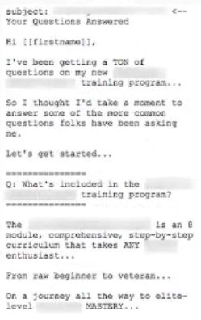

example FAQ email subject line: Ryan’s Guarantee Course

I like to break the email up into sections, where each email is highlighted in this way:

========
[Question #1]
========
[Answer #1]

[Link back to product]

========
[Question #2]
========
[Answer #2]

[Link back to product]

========
[Question #3]
========
[Answer #3]

[Link back to product]

And so on…

(we’ll get to the close for the email in just a sec…)

Question #1 – What is it?

What is the offer?

You’re not really embellishing the language at all, you’re just saying…

“Here’s what you get:”

Example from ‘Rocket Memory’ course:

“So, what is the Rocket Memory rapid results 10 day course?

It’s a 10 day course that includes a set of DVDs…

A 300 page workbook…

Along with a set of 10 cheat sheets and flash cards…

That are designed to take you from where your memory is today…

To dramatically improve it in just 10 short days…

By investing an hour a day…

In the exercises provided…”

So it would be something like that…

The next question you want to ask is…

Question #2 – Are there any bonuses?

“Yes there are bonuses.

In fact, there are 3 of them…

Let’s talk about what they are, one by one…

Bonus #1 is this:

[Describe bonus #1 ]

etc…”

The next question I like to ask is…

Question #3 – How much does this program cost?

And this is where you juxtapose it against the normal price:

“Well, normally this program costs [X]…

And the bonuses would cost you [Y]…

But as part of this special program that we’re offering right now…

It’s at [Z] price…

Which is a savings of over 75% off [or whatever %]…

Saving you over $200 dollars…

Here’s the link if you’d like to take advantage of this special opportunity…

Again, the structure for each of these questions is…

========
[Question]
========
[Answer]

[Link back to product]

And that’s the FAQ email…

[video timestamp 1:13:00 ]

Questions I like to ask in the FAQ email:

What is it?
Are there any bonuses?
How much does it cost?
How is it delivered?
(especially if you’re sending something by mail or if it’s a digital product…)
Is there a guarantee?
You say, “Yes there’s a guarantee!” and then you spell out what it is…

Some other possible questions:

“What’s the difference between this product and that product?”
“Is there a limit to how many I can order?”

And here’s the reason why I like to end with guarantee…

“Lastly, if you still have any unanswered questions not covered here…

Here’s what I recommend:

And this is where you get into the ‘Invisible Close’ language that I’ve adapted from Lisa Sasavich that I use in a lot of my stuff:

“Lastly, if you have any unanswered questions about the XYZ program…

Here’s what I recommend:

Because you’re protected by the 60 day guarantee [or whatever your guarantee is]…

Meaning…

You do not risk a penny by taking advantage of this special opportunity now…

Here’s what I recommend:

Don’t try and decide if this program is right for you…

Instead, grab your copy now before we [sell out / reach deadline / etc. – whatever the reason to act now is in your particular offer…]

Grab it now before we sell out…

Take it home…

Try it out…

Take a full 60 days to play around with it…

If you like it?

Keep it.

If not, no problem, simply send it back to us or simply let us know with a one-line email…

And you’ll receive a fast and courteous refund…

No questions asked, no hassles and no hoops to jump through either…

It’s really as simple as that…

Here’s the link one last time…

[Link]

Talk to you soon,

Ryan

So that’s basically what that FAQ email looks like…

[ video timestamp 1:16:15 ]

Testimonial Email

The next email that I like to put in there is a testimonial email…

After I sent out my FAQ email, people have been wondering about whether or not any other people have had any success with the program or product…

So I thought it would be helpful if I gathered a whole bunch of comments that I’ve gotten from people over the years [or whatever your timeframe is]

And put them here to help you better decide if the XYZ product is right for you…

So here they are…

(Screenshot of email starts next page…)
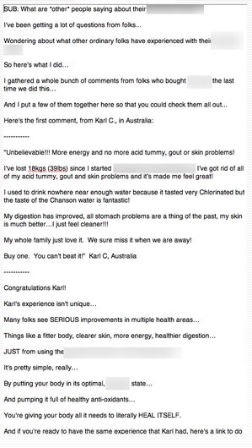

This is pretty good…

But even better is to…

Include the most believable form of testimonials I’ve found, short of video testimonials or audio…

Is to take screenshots of things in legit places

The most notable of which is Facebook Comments

If someone has said something great about you in a facebook comment?

Grab a screenshot of it and either put the link to the screenshot,

Or put the image itself in the email

OR – you can put the comment in text so people can read it, and then you put a link to the facebook comment below that…

Like this..

“This product was unbelievable!”

To see Carl’s complete story, click here:

[link]

- and then either send them to the actual facebook post, or link them to a screenshot

You’re just increasing your credibility and trust by sending them to a real testimonial said by a real person…
- can also use google reviews, yelp, or anything else that’s legit

Next email…

Irresistible Offer Email aka “I’ve decided to do something CRAZY” email…

This one is kind of optional, but I’ll explain more about it in a sec…

This email is optional, because it won’t always apply in all situations…

But typically, what I like to do is this..

In general, I like to position whatever the offer is that people are getting after the survey funnel…

As being a special offer…

So it’s BETTER than advertised…

Like…

“If you were to go on our website right now and try to buy this, it’s going to cost you $100 bucks…

But you can get it today for just $50 bucks…

Awesome deal…

Etc…”

So there’s a reason to buy now, all the way up until this point….

And at this point in the email sequence, you’ve captured all the people that are going to buy without any additional coaxing…

But you’ve still got a lot of people who are sitting on the fence…

A lot of people who are saying “It could be worth it… BUT… I need something to sweeten the deal…”

And that’s where I like to do this “I’ve decided to do something crazy” email…

And I do it in a number of ways, but here’s how I like to do it here:

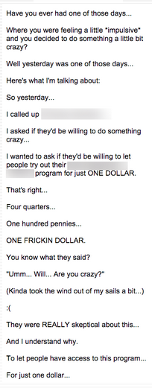

What we’re doing here…

What we’re doing is letting people access the product that they want – the product that they’ve been opening up emails for for the last few days…

Either for free OR for a dollar…

Not free or for a dollar forever…

But lowering the threshold to try the product…

We’re giving them a trial…

We’re giving them access to a risk-free trial,

To try the product either for nothing
(enter credit card info now, won’t get charged for 14 days…)
(or, pay $1 now just to cover processing, and then if you like the program, keep it and in 14 days you’ll be billed the remainder…)

We’re lowering that threshold to let people try the product for free…

KEY POINT

So, why did we do that vs. lowering the price further or doing something else?

Well, I don’t like to give people a better deal than the one that your fast action takers got…

- so if you’re selling a product for $40 or $50 on the front end…

You don’t want to reward people who DIDN’T take action and waited…

Because then it just creates a whole bunch of bad blood – your current customers are going to see that they got a worse deal, and they’re going to be mad.

[video timestamp 1:22:03 ]

Most importantly…

If you do this, you’ll be training your audience to WAIT and NOT take action – which is not what you want…

Why do we do it in the following order?

- FAQ
- Testimonial
- Low Threshold offer

The reason why is because people respond to different mechanisms…

This gets into some personality architecture –
Some people have sort of engineer-type brains
(“Just the facts ma’am” type people…)
- respond to FAQ email
Other people are more moved by stories
Motivated by hearing about someone’s success
    - respond more to testimonial email
Other people are procrastinator types
    - only time they’ll do anything is if there’s a fire under their ass to get it done
  - they respond to the ‘crazy offer’ email
    - because it’s EXTREMELY limited time – people get a 24 hr or 48 hr window to do that
- and this is where the ‘deadline funnel’ comes in
    - this software – which you’ll get access to as part of the ongoing training – allows you to execute the deadline with a countdown timer in your emails

Next email

Follow up to irresistible offer email

Last day email

Last Day Email

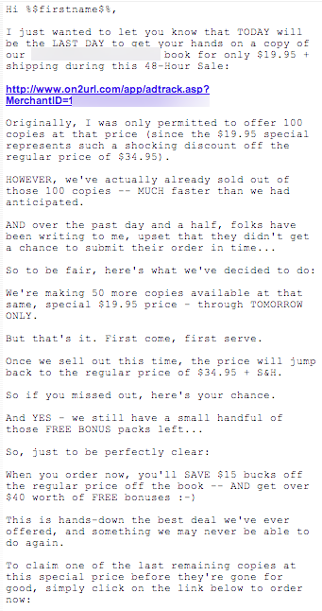
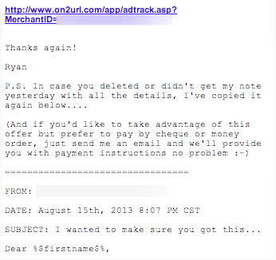

Another reminder about special offer, plus forwarding technique – forwarding previous email

It’s a follow up to the irresistible offer

And then, after that, is our famous… “Do you hate me?” email

Do You Hate Me? Email

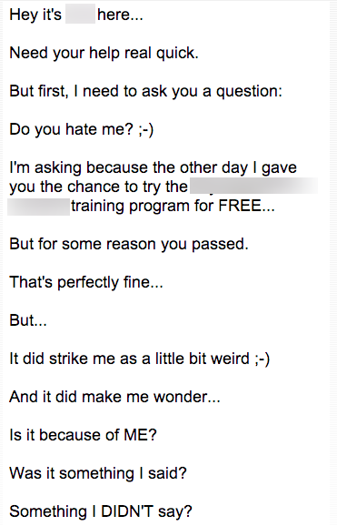
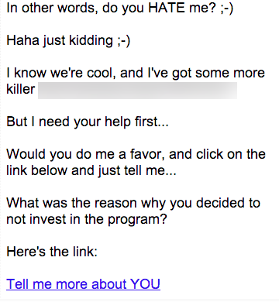

And this is where we’re gathering some open-ended survey intelligence, to where we’re trying to figure out what were the reasons why that person ended up not buying…

Did we not explain it well enough?

Did we not touch on a particular hot button?

And that sets you up to do one of two things…

- A re-open of the offer
  - Where you can say, “Hey listen, I realize that I didn’t do a good enough job of explaining a couple things, so I wanted to extend the opportunity to try out the program for a dollar offer…” for another 24 /48 hrs… For anybody who missed it… and here are the reasons why:
    - And then you can go over the issues that people brought up as the reasons why you are going to re-open the offer

[video timestamp : 1:32:00]

- Sets you up for the ‘pivot email’

Pivot Email

This is where we’re sending people to a different list based on the one they click on …

There a couple different ways you can do this, but if you signed up for my mastermind and have access to my software, you can do both of these surveys with the software…

So that when someone clicks on a link, they are automatically subscribed to that particular list.

Screenshot of pivot email below:
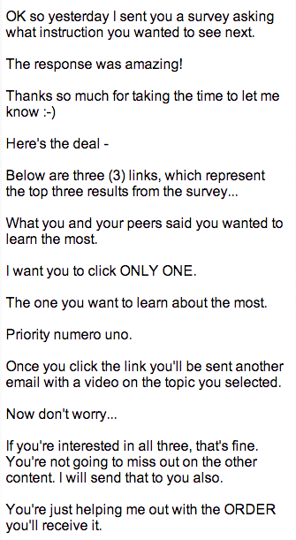
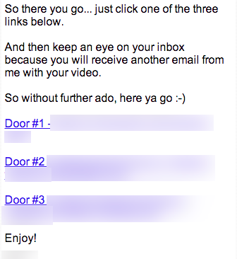

Buyer Email Sequence

Overall structure of customer email sequence…

[video timestamp 1:34:00 ]

Buyer customer sequence is different than prospect sequence, because prospect sequence, they didn’t buy and you’re trying to send them to something else…

From a customer sequence perspective, there are what I like to call the “3 conversions”

The 3 Conversions

The 3 conversions concept is the idea that if you can get someone to convert 3 times, then you will have a customer for life…

Now, the 1st conversion – is going through the survey process, entering their name and email, and opting in – that’s the first conversion…

The 2nd conversion is converting into a customer – buying whatever the product is that you sold them.

But the 3rd conversion is actually the most important…
And that’s to actually get them to consume the product and TAKE ACTION on it…

Because, if you’ve ever bought anything and done NOTHING with it…
If that person tries to sell you something else, what happens?

Your reaction is generally, “I didn’t even get a chance to implement the first thing I bought from this person…”

That 3rd conversion is SO important…

So what you want to do when it comes to your customer sequence is…

#1 – consumption – getting them to consume

#2 – enhance the purchase – (we’ll talk about that in a second)

#3 – pivot email – pivoting to a new direction

Those are the 3 main parts of the customer sequence…

What do those parts look like?

#1 – Consumption
- 1st email: that goes out is ‘Congratulations’
  - “hey, congratulations on investing in XYZ program, I think you’re going to be thrilled with what you discover… In fact, if you’re like most people, this is going to be the most powerful thing that you’ve ever tested or tried… blah blah blah… Listen I gotta run because of XYZ reason, so I’m going to keep this email short… But stay tuned because I’ve got more great stuff coming right around the corner… Talk soon, Ryan”
  - That’s the first email
- 2nd email: ‘The #1 Thing to Focus on’
  - This is where you want to give people a very hyper-specific action step that you want them to take with your product…
  - SUPER specific…
  - “Hey, it’s Ryan here… And I know you’ve got probably a lot of things going on in your life right now… but listen… What I’ve noticed is that the thing that separates people who are successful from the people who don’t do ANYTHING with this information that you’re about to get your hands on… Are the people who take small action steps every single day… So I want to give you one tiny little thing that you can do today which is the single most important step you can take towards your goal of achieving X… And that’s this: I want you to turn to page 37 in the book… I want you to skip to 13:17 in the video… And I want you to listen to that segment… And I want you to do one thing… I want you to write down the answer to this question: That’s it. That’s ALL you need to do today… This will take you less than 2 minutes… But believe me… This is THE #1 thing that separates successful people from those who never make any progress… So just do this ONE specific thing…
  - That’s the 2nd email – Day #2
  - This needs to be a ‘big picture’ action step, like…
    - “I want you to identify the three biggest buckets in your market just intuitively, who do you think are the 3 biggest sub-segments in your market?”
      - And then I want them to go back into the product – so I send them to a SPECIFIC piece of the product
      - I know that if they end up watching 2 minutes, they might end up watching 15 minutes because it’s just so damn good…
        - Just a taste…
    - Tell me what the 3 biggest segments are in your market, and tomorrow I’ll explain what you’ll do with that information…
- 3rd Email – Doing a very specific action / drill /exercise for 3 days in a row…
  - “Ok, so what I want you to do for today, is for each of those 3 buckets you’ve identified… I want you to write a 1 paragraph description of who that person is… For example… It could look like this…
  - [and I’d redirect them to a part of the product that explains when to do that specific thing…]
  - “So what I want you to do today is jump to video 2… 2:23 into the video… And I want you to do the exercise that I explain at that point… And I want you to do that for each of your 3 buckets… It’ll take you less than 2 minutes per bucket… Less than 10 minutes total for the exercise… But go ahead and do this… We’re going to be moving things along and then tomorrow we’re going to use that information to answer another important question that is going to lead you in the right direction…”
    - And then for 4th and 5th emails, you’d have exercises 2 and 3…

So…

You’d do this over the course of 5 days:

- Welcome email
- #1 thing you must do email
- Exercise #1
- Exercise #2
- Exercise #3
- “Catch-up” Email
  - “Ok so today, we’re going to take a day off… I know maybe some people haven’t had a chance to catch up with everything… And by the way, if you didn’t get all my emails over the last couple days, here they are: [link] [link] [link] … “
  - That’s a catch-up email, b/c you don’t want people to feel like they’re falling behind… Where they’re missing out on something… You want people to feel good about themselves.
    - You don’t want people to feel so overwhelmed and behind that they feel like they should cancel the program
  - You want to have 2 paths going on-
    - 1. People who are moving fwd at an aggressive pace
    - 2. Something in between for people who didn’t get around to everything – that’s the reason for the ‘catch up’ email

That’s SIX emails of pure consumption…

Then, if you have more stuff to sell people, which you should…

This is where you want to start turning the corner to the next section of the customer sequence, which is…

[video timestamp 1:43:00 ]

Enhancing the Purchase

This is where you say…

Talk about how to make things easier, faster, better, or more fun…

By using some tools…

You’re writing about consuming the main product that they bought…

Example for info product:

“Now you might have noticed in the video for exercise 2, that I was using a little piece of software to make things easier… Well, that piece of software happens to be a piece of software that I own… And if you’d like to get access to it… I have a special program… Normally it costs this, but I have this special program for customers where it only costs [X]. Now most people who go through the program eventually like to invest in the software b/c it makes their life so much easier & faster… And the process is a lot more painless… ”

What we’re doing here is…

Getting people to invest in the other stuff that you have to sell that augments their original purchase…

Example – weight loss supplement – here’s where you’d sell exercise gadget… etc.

Can also introduce 3 different things, and at the end say…

“Hey, folks who have been interested in getting access to all these things but they weren’t quite ready to pay all those individual fees… Well the good news is I have a special package where you can get access to all these additional tools I just talked about… At a fraction of the price… “

And then you can go through the other emails:

FAQ
Testimonial
Last Day
Pivot
Pivot copy example:
“Hey, I know we’ve been talking a lot about [x], But I know some folks are interested in covering some other topics… So if you tell me what you’d like to learn about next, we’ll switch gears… [door #1 / #2 / #3, just like in prospect pivot email]

Email Formatting

You’ve probably noticed how I format my emails, with the narrow column and large font…

There’s a reason –
- a narrow column is much easier to read than a wide column

There’s a specific template that I send out where I want to make my emails look as personal as possible, and I’m doing this narrow column…

You have to send it out using an html template

Which will make it look like this in Gmail on your computer:

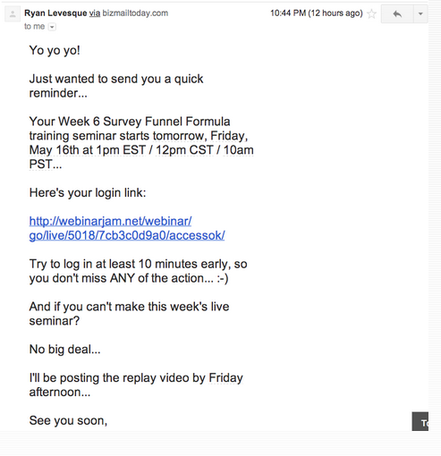

And it will look like THIS on iphone:

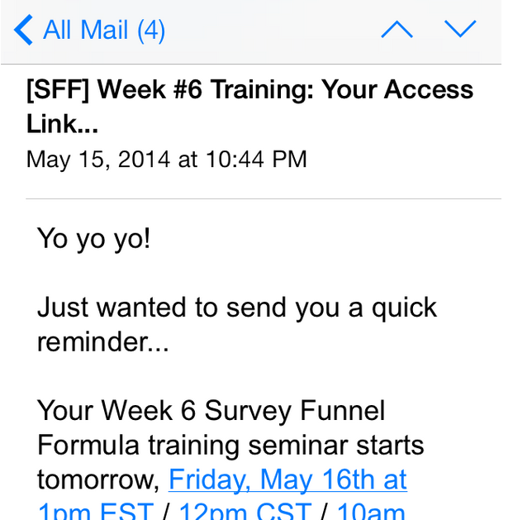

This template is in the member’s area for week 6 – check it out…

Now if you DON’T use an html template…

Just in plain text?

Then when your email shows up in mobile, it’s going to look like this:

With really awkward line breaks:

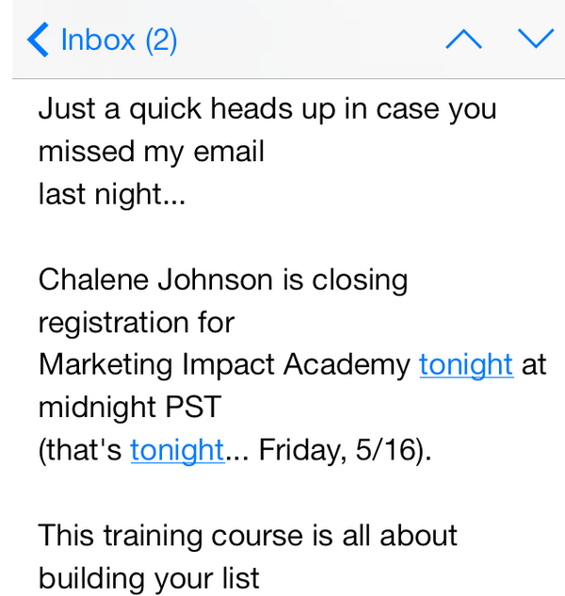

OR—

Another reason to use the template and to get your font size right…

When the font size gets screwed up, here’s what it looks like:

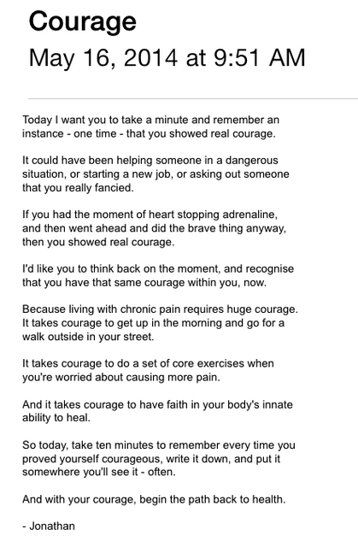
You can’t even read it!

So again, use the template I gave you in the member’s area…

Q&A are on this week’s transcript.

